***Child Tracker With Emergency Notifier.***

**INTRODUCTION:**

* 1. Overview

Internet of Things (IoT) plays a major role in every day to day life. The major difference between IoT and embedded system is that a dedicated protocol/software is embedded in the chip in case of embedded system, whereas, IoT devices are smart devices, which are able to take decisions by sensing the environment around the device. The development of sensors technology, availability of internet connected devices; data analysis algorithms make IoT devices to act smart in emergency situations without human interventions. So, IoT devices are applied in different fields such as agriculture, medical, industrial, security and communication applications[1]. IoT systems are useful within a system to do deeper automation, analysis, and integration. IoT contributes to technology by advances in software, hardware and modern tools. It even uses existing and upcoming technology in the fields of sensing, networking and robotics. IoT brings global changes by its advanced elements in the social, economic, and political impact of the users.

1.2 Purpose

Child Tracker with Emergency Notifier an IoT-based system that sends dataof children who are in the geofence via web/mobile application.The main moto of this creation of the Child Tracker with Emergency Notifier is that to check whether the child is in a desired area oh crossed the particular area.

**LITERATURE SURVEY:**

2.1 Existing problem

As we are in this 21st century everyone is busy in their own life so directly or indirectly we are connected with the emerging technology. We cannot monitor the things perfectly so with the help of this Child Tracker with Emergency Notifier an IoT-based system we can keep eye on children that where they are moving.

2.2 Proposed solution

Solved the problem by application “Child Tracker with Emergency Notifier an IoT-based system” Client server based approach used in the architecture. The registration of client phone done by server and after that login saved in database of server. Then client sends location coordinate updates to server the updates saved in database of server. Then with the help of Location Updates the location is tracked. This application was developed for helping to locate the children.

**THEORITICAL ANALYSIS:**

3.1 Block diagram

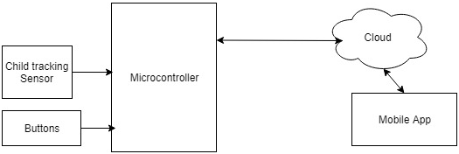

3.2 Software design

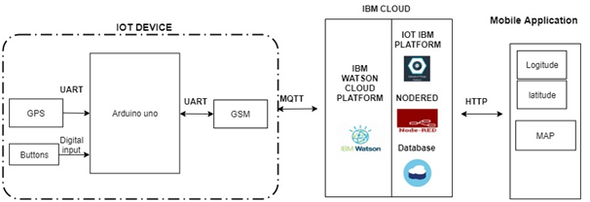

**FLOWCHART:**

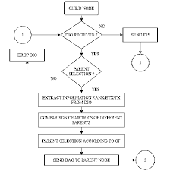

**RESULT:**

The project “Child Tracker With Emergency Notifier” was designed such that the status of children can be known from anywhere in the users webpage. This is achieved using Wi-Fi communication.

**ADVANTAGES:**

Application automatically operates location requests without user interaction because at that time child not have knowledge to update his location at map. Another advantage is that application uses SMS when internet connectivity is not available. The system requires location and telephony services.Third advantage is it can be used at indoors where GPS satellites connectivity is not available. At that time it can uses network provides for location services. Network provide service uses cellular ID such as IMEI number for location tracking. Lastly all the controls are in parent side. The child side have less control access.

**DISADVANTAGES:**

Consider any system that always have advantages and disadvantages also.The application have certain disadvantages that can be overcome.The application is not worked well when there is no network available.In that case the application fails the exact location.But the applicatiaon stores the last location which can be stored at the database server.When mobile is switched off then we consider this as a one of the drawback of system.

**APPLICATIONS:**

Wherever we need to monitor our child we can use this application which is in the form of apk in the mobile as well as system.

**CONCLUSION&FUTURE SCOPE:**

In conclusion project was designed for locating missing or lost children. This project was given depth information about child tracking system with the help of two components such as GPS and GSM telephony services the application is built in. Finally for this application has room for enhancement. Geo-fencing , Emergency alerts such features can be added to enhance system. The proposed system will be improved in later work.